

FACULTY OF TECHNOLOGY AND ENGINEERING
DEVANG PATEL INSTITUTE OF ADVANCE TECHNOLOGY
AND RESEARCH

DEPARTMENT OF COMPUTER ENGINEERING

A.Y 2026 – 27 Semester – 3

LAB MANUAL

CSUC201 Fundamentals of Data Structures and Algorithms


Practical 10: Hash Tables: Linear Probing, Chaining, and Double Hashing
Practical Aim
To implement hash tables using different collision handling strategies and develop the ability to reason about why collisions occur, how different strategies resolve them, and what trade-offs each approach involves.
Problem 1
A small parking lot has exactly 10 numbered slots (0 to 9). When a vehicle arrives, its registration number is used to assign it a slot by taking the last digit of the number. If that slot is already taken, the vehicle moves to the next available slot in order, wrapping around if necessary. Given a sequence of vehicle registrations, assign each to a slot using this rule and display the final state of all ten slots.
Describe what your solution does when it encounters an already occupied slot. What happens when the parking lot is nearly full and many vehicles keep landing on the same slot? Can you think of a situation where your solution might loop indefinitely?
Theory:
- If five consecutive vehicle registrations all end in the same digit, trace where each one gets placed in the parking lot. Now explain why this clustering effect is astructural weakness of this collision strategy — not just for this input, but in general.
Suppose five vehicle registrations all end in digit 3. The first vehicle occupies slot 3, and the remaining vehicles occupy slots 4, 5, 6, and 7, respectively. This happens because linear probing checks the next slot whenever a collision occurs. It causes primary clustering, where groups of occupied slots grow together, increasing the number of checks required for future insertions and searches.
Code: https://github.com/kanan2007s-sys/FDSA_B/tree/main/Practical%201

Screenshot:
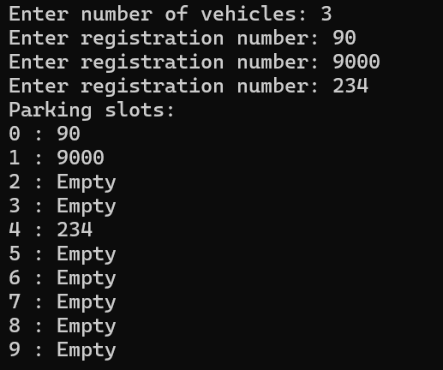

Description:
This program implements a hash table using linear probing to assign vehicle registration numbers to parking slots. It uses the last digit of each registration number as the hash index and searches for the next available slot if a collision occurs, wrapping around to the beginning when necessary.
Challenge:
Handling collisions when multiple vehicles map to the same slot, implementing circular probing correctly, and preventing an infinite loop when the parking lot becomes full.

Problem 2
A library uses a system with 10 shelves numbered 0 to 9. Each book's code is used to decide which shelf it belongs to by taking the code modulo 10. Unlike the parking lot, each shelf can hold multiple books stacked together — when two books map to the same shelf, they are simply added to that shelf's stack. Given a sequence of book codes, place each on the correct shelf and display the final contents of all shelves.
Describe how your solution handles two books that map to the same shelf. What happens to search time on a shelf as more and more books pile onto it? Can you think of what would cause all books to end up on the same shelf?
Theory:
- Suppose all book codes in Problem 2 are multiples of 10. Without tracing through the code, predict what the final shelf layout would look like and explain why. What does this tell you about the relationship between the hash function and the input data?
Since every book code is a multiple of 10, the remainder when divided by 10 is always 0. Therefore, all books will be stored on shelf 0, while shelves 1 to 9 remain empty. This shows that the efficiency of a hash table depends on how well the hash function distributes the input data. Poor distribution causes long chains and slower searching on the affected shelf.

Code: https://github.com/kanan2007s-sys/FDSA_B/tree/main/Practical%201

Screenshot:
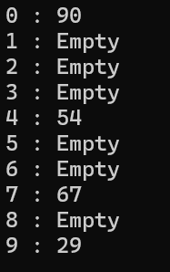

Description:
This program implements a hash table using chaining to store book codes on library shelves. It calculates the shelf number using the book code modulo 10 and stores multiple books at the same shelf using a linked list or another collection.
Challenge:
Managing multiple book codes at the same shelf, maintaining the correct order of insertion, and understanding how searching becomes slower when many books are stored in a single chain.

Problem 3
A university assigns student IDs to storage slots using a two-step rule. The first rule determines the initial slot. If that slot is taken, instead of simply moving one slot forward, a second rule based on the ID itself determines how many slots to jump. This means different IDs that collide will probe different sequences of slots, spreading them more evenly. Given a sequence of student IDs, assign each to a slot using both rules and display the final state of the table.
Describe how your solution decides how many slots to jump when a collision occurs. What is the risk if the jump size happens to be a factor of the table size? How does this strategy differ from Problem 10.1 in how it spreads collisions?
Theory:
3. what would happen if the second rule always produced a jump size of zero? Trace through the consequence and explain how this failure is related to the choice of the second hash function rather than the data itself.
If the second hash function always returns zero, the probe sequence never moves away from the initial slot. If that slot is occupied, the program repeatedly checks the same slot and may enter an infinite loop or fail to insert the student ID. This problem occurs because the secondary hash function is incorrectly designed. It should produce a non-zero jump size that allows the probing sequence to reach available slots.

Code: https://github.com/kanan2007s-sys/FDSA_B/tree/main/Practical%201

Screenshot:
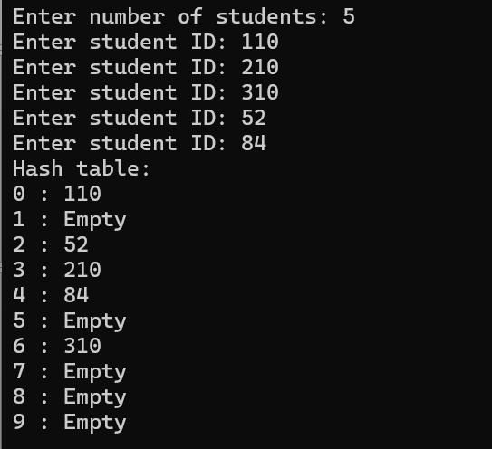
Description:
This program implements a hash table using double hashing to store student IDs. It uses a primary hash function to find the initial slot and a secondary hash function to calculate the jump size when a collision occurs, helping distribute IDs more evenly across the table.
Challenge:
Selecting suitable primary and secondary hash functions, ensuring the jump size allows the program to reach available slots, and avoiding repeated probing when the jump size is zero or shares a common factor with the table size.

Conclusion:
Successfully implemented three hash table collision-handling techniques: linear probing, chaining, and double hashing. Understood how collisions occur, how each technique resolves them, and how clustering, chain length, and probe sequences affect the efficiency of insertion and searching operations.

